Set 1

Q1. Write a Python function to calculate the factorial of a number. Use a coding assistant and document how you refine your prompt to ensure the function handles negative input and zeros.
(Each question carries 5 marks)

Prompt: write a python function to calculate the factorial of a number, also handle the edge cases such as negative numbers and zero as input.

AI Generated Code:
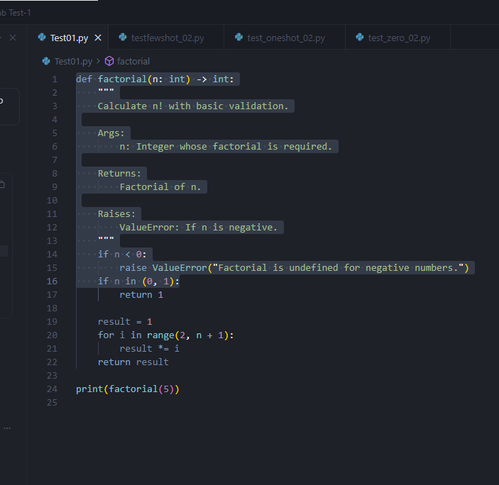

Output:
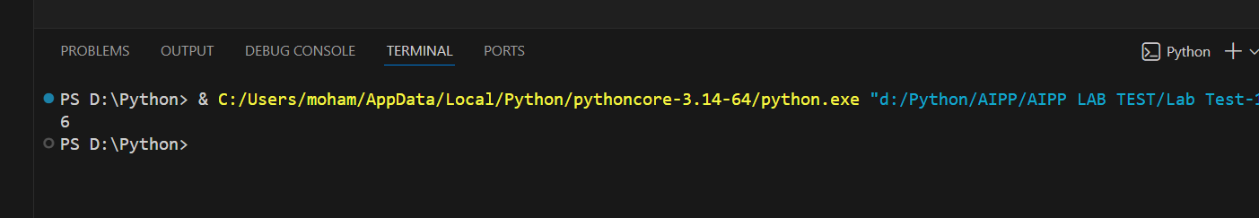

Q2. Given a list of student marks, compute the mean and list all students above the mean. Demonstrate zero-shot, one-shot, and few-shot prompts to guide an AI tool to solve this. Summarize the differences in approach.
(Each question carries 5 marks)
Zero-shot Prompting
Prompt: generate a function to calculate the mean of the students_marks list and then list the student_marks that are greater than the calculated mean.

AI Generated Code:
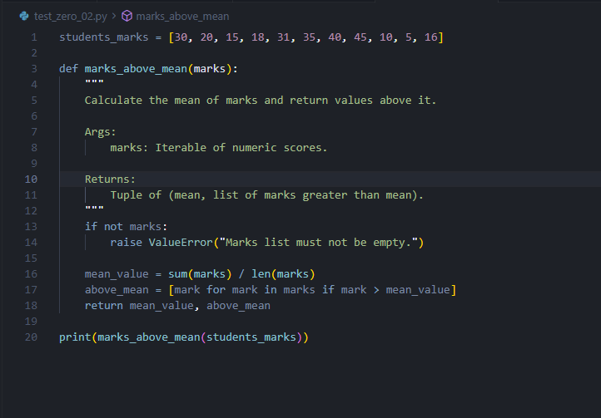
Output:
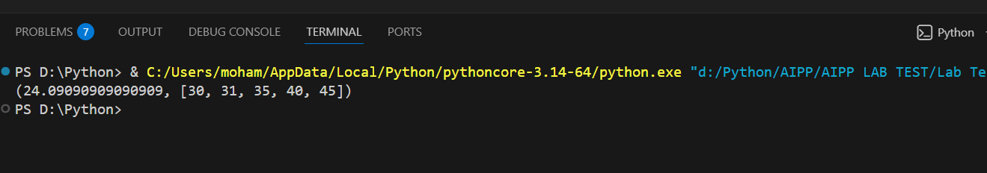

One-shot Prompting

Prompt: generate a function to calculate the mean of the students_marks list and then list the student_marks that are greater than the calculated mean. For example:
for input of student_marks = [1,2,3,4,5] to the function it should print:
Mean value = 3, Students marks greater than the mean value i.e 3 = 4,5

AI Generated Code:
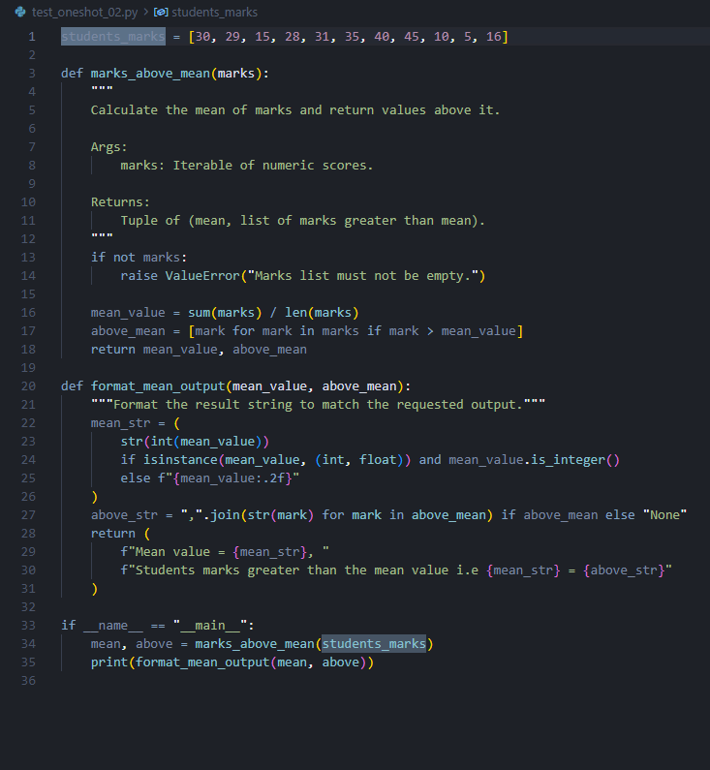
Output:
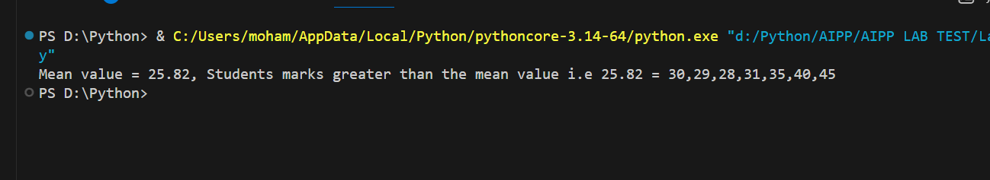

Few-shot Prompting

Prompt: generate a function to calculate the mean of the students_marks list and then list the student_marks that are greater than the calculated mean. For example:
for input of student_marks = [1,2,3,4,5] to the function it should print:
Mean value = 3, Students marks greater than the mean value i.e 3 = 4,5
for input of student_marks = [1,'2','3',4,5] to the function it should print:
Mean value = 3, Students marks greater than the mean value i.e 3 = 4,5
(here the string values, if they can be converted to numbers then convert and find the mean, the students marks greater than mean)
for input of student_marks = [1,'2','-',4,5] to the function it should print:
Invalid values in the students marks list
(here the string values cannot be converted to numbers)

AI Generated Code: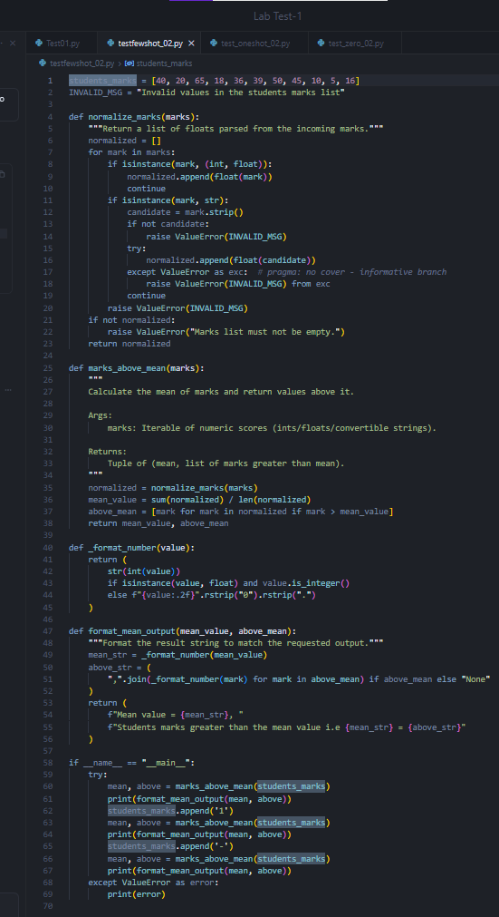

Output:
